Ai lab Task 5(3)
Written work screenshot:
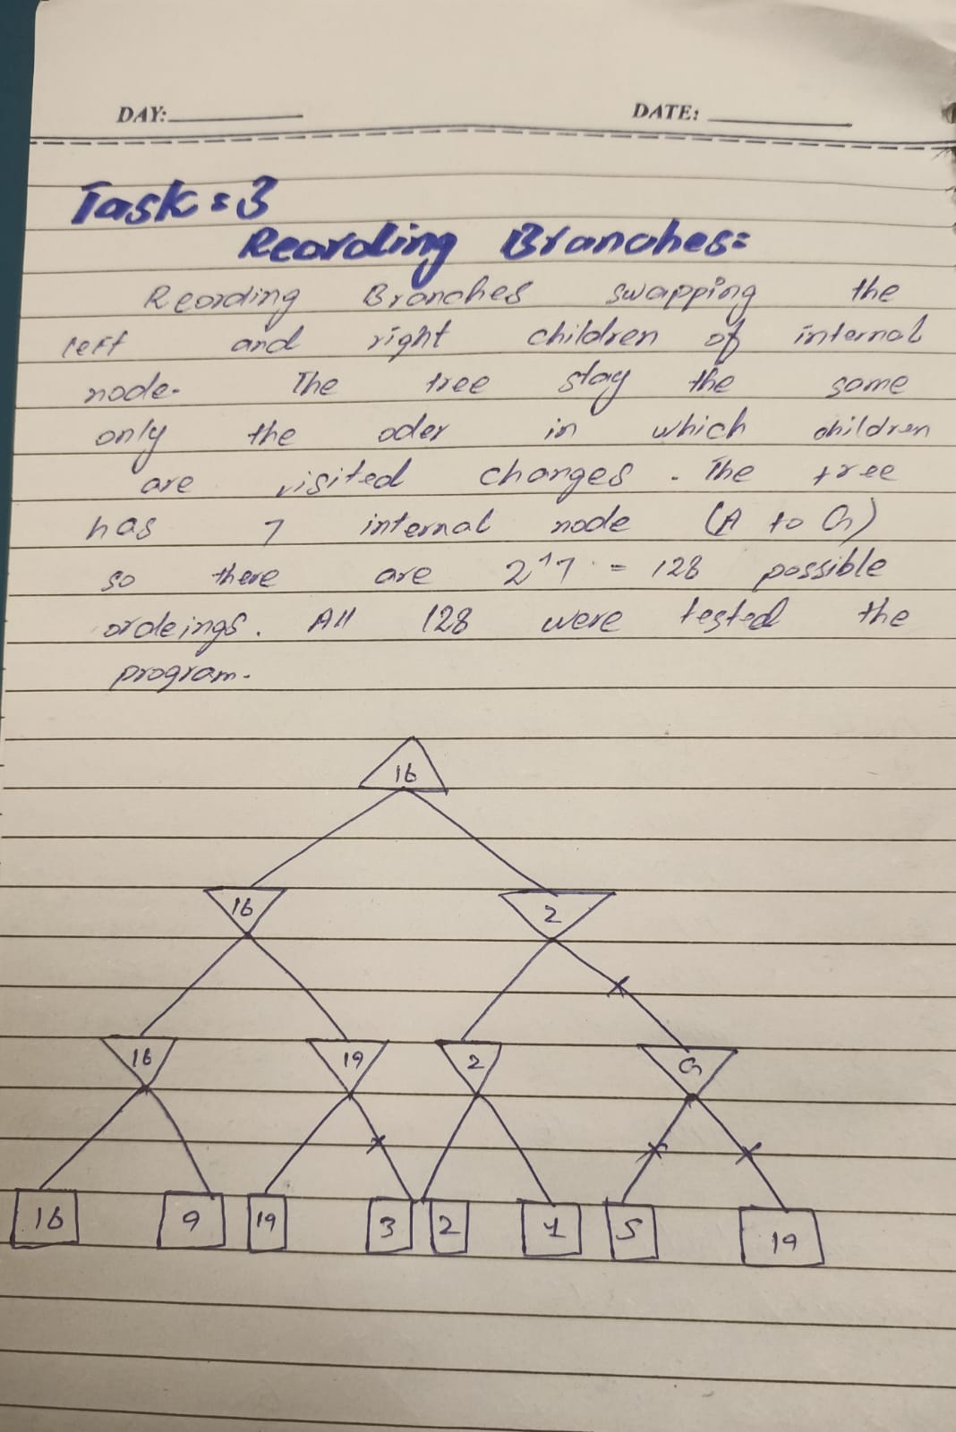
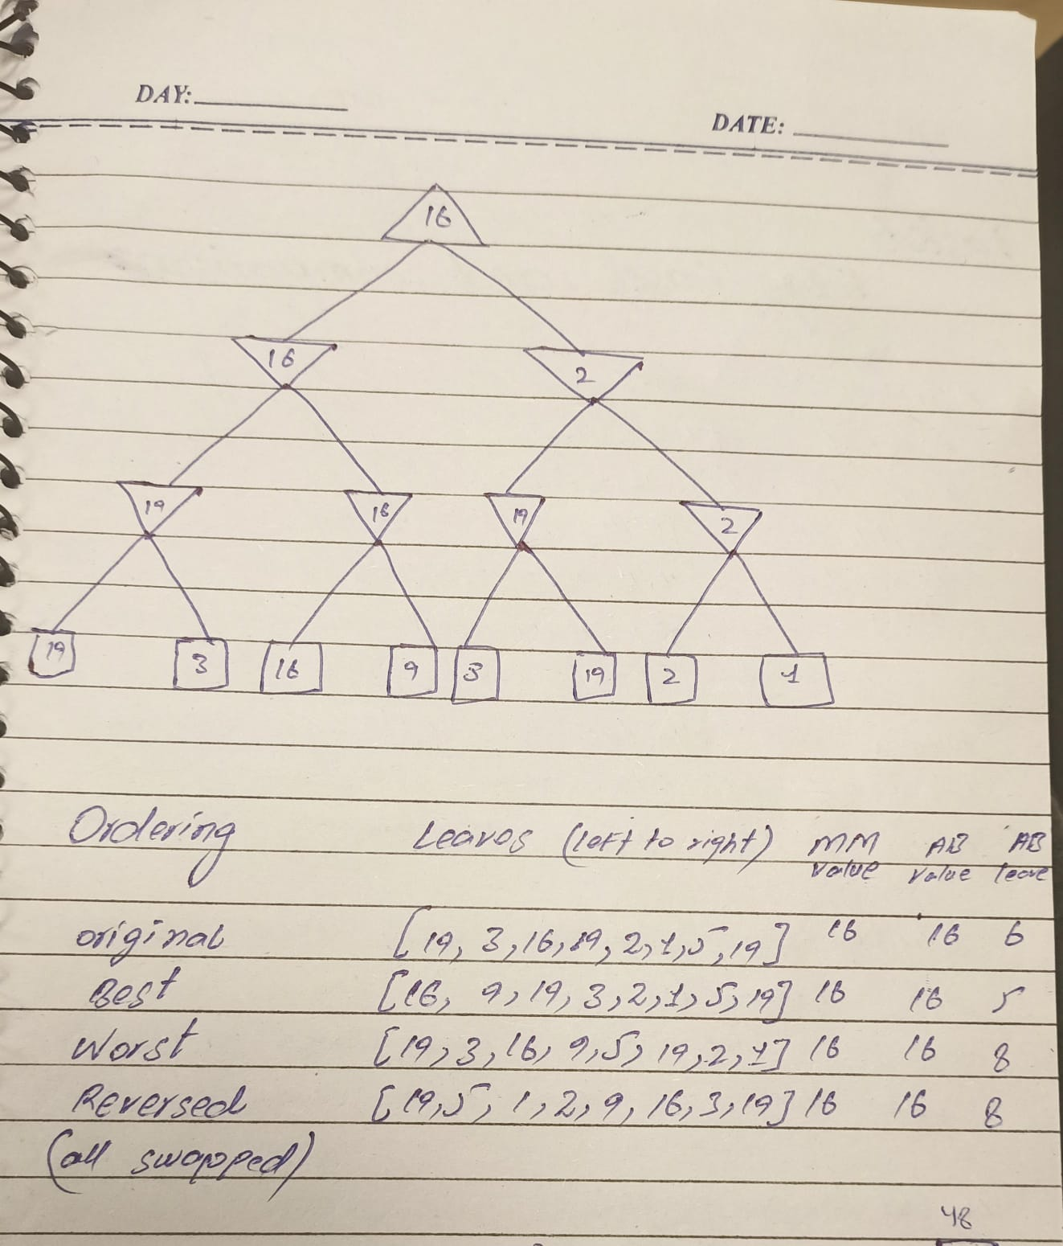
Task Output screenshot:
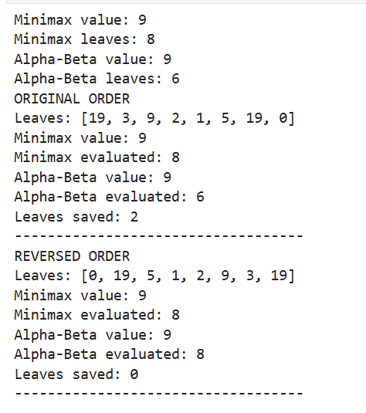

Conclusion:
Conclusion: The optimal value remains 9 in both cases. With the original branch ordering, Alpha-Beta pruning eliminates 2 leaf evaluations, whereas with the reversed ordering, no leaves are pruned. This demonstrates that branch ordering affects pruning efficiency, but a correctly implemented Alpha-Beta algorithm should not change the final Minimax result.

